EXP 14:

AIM: Design PDA using simulator to accept the input string a^nb^2n

INPUT:

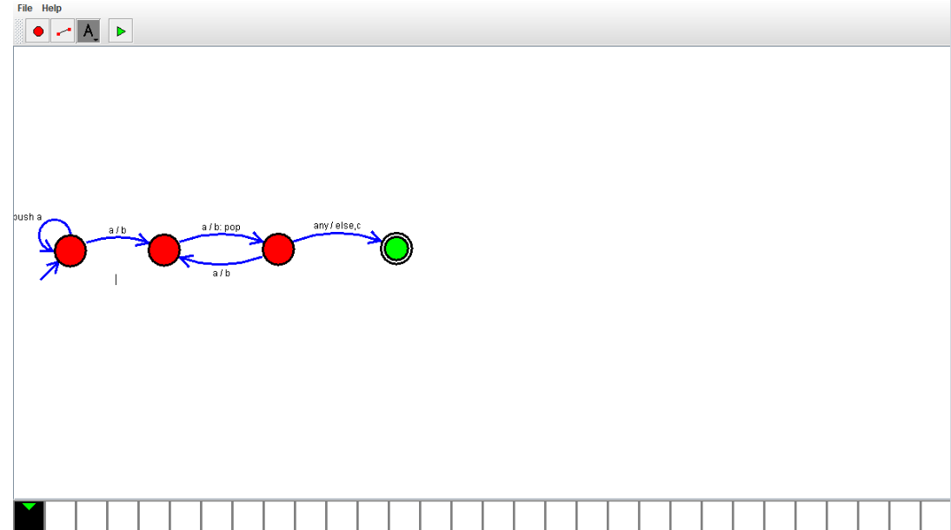

Output:



Result:

Design PDA using simulator to accept the input string a^nb^2n is successfully verified